GIT-GITHUB-TASKS: Batch-16 Mohammed Mujahed

1. Install git.



STEPS: to install git yum install git.

<git --version> tocheck which git version is using.

1. Create a repo in github with README.md and .ignore file.

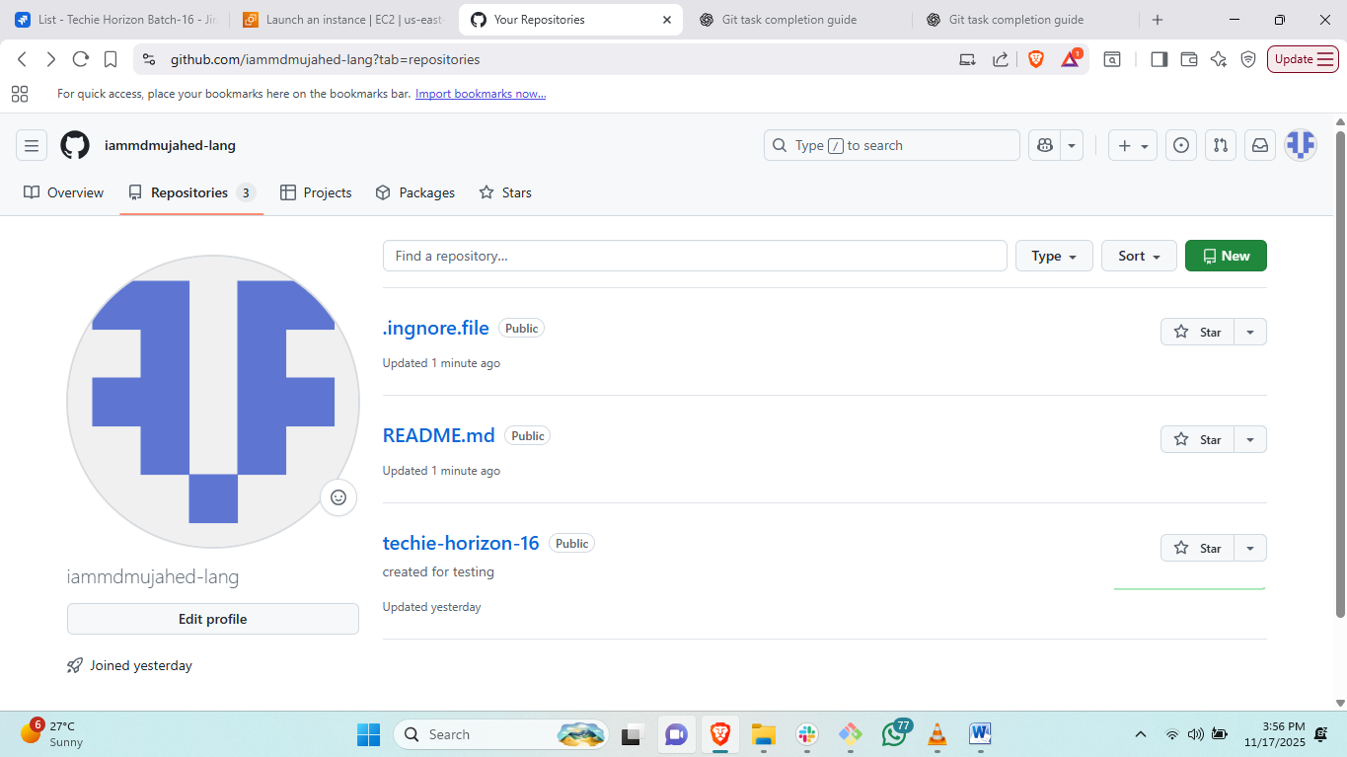

Steps: to create repository login to github account and click on repositories and add new

Then create new repository.

1. Clone the created repo to local.

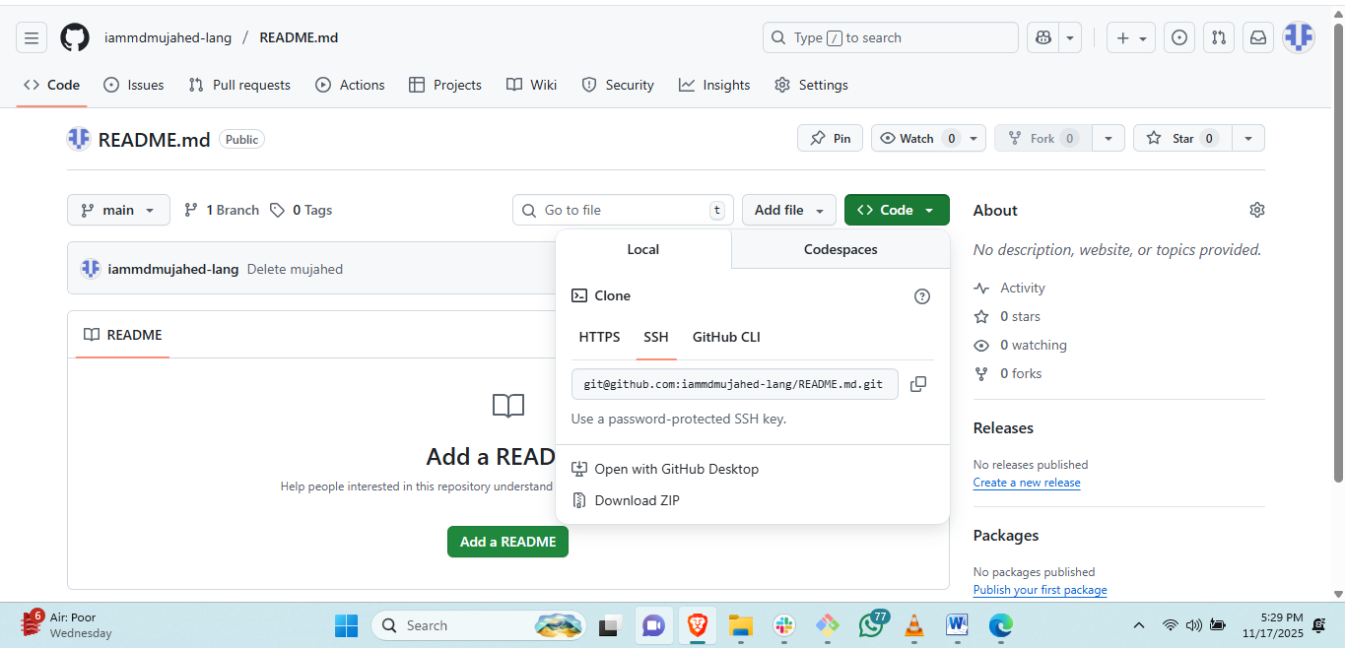

Go to created repo and copy ssh URL  
then # <git clone “URL”> in local machine git.

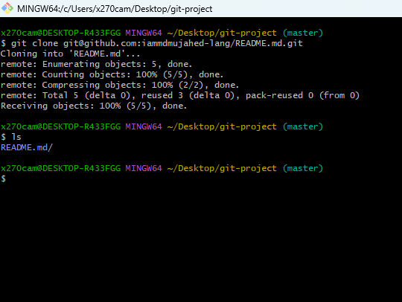

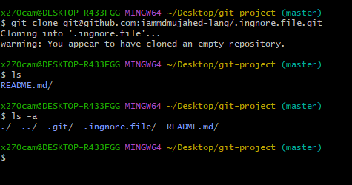

# the repository is started with .ignore.file will be hidden.

1. Create two files in local repo.

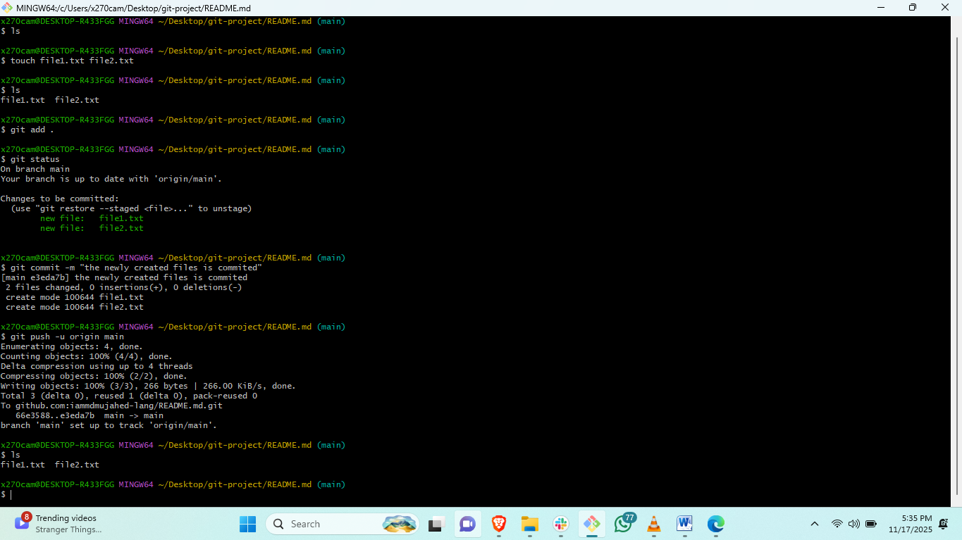

Steps: go to README.md directory and create two files with touch command.

# <git add file1.txt file2.txt>and commit the tracking files with <git commit –m “message”>

# <git push –ui origin main> to push the commited file to central repository

1. Commit two files and push to central Repository.

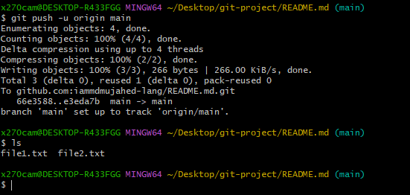

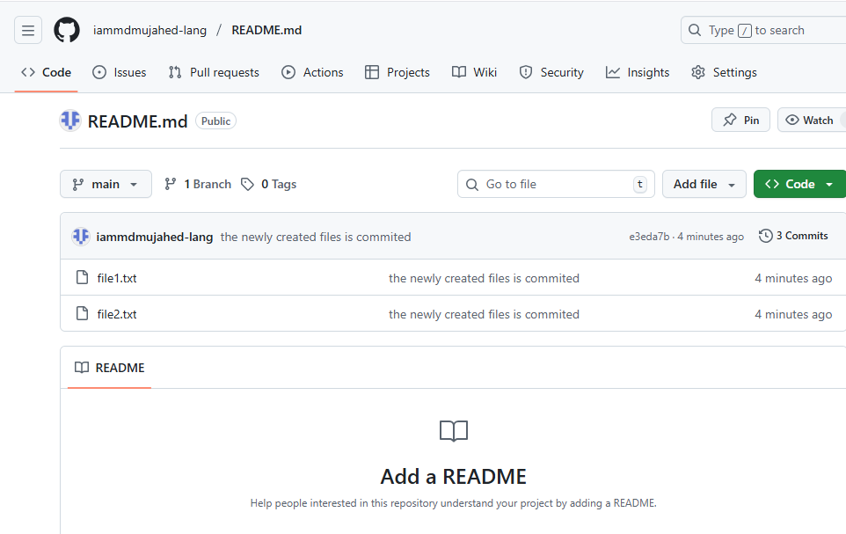

Steps: # <git push –ui origin main> to push the commited file to central repository

1. Create a branch in local and create a sample file and push to central.

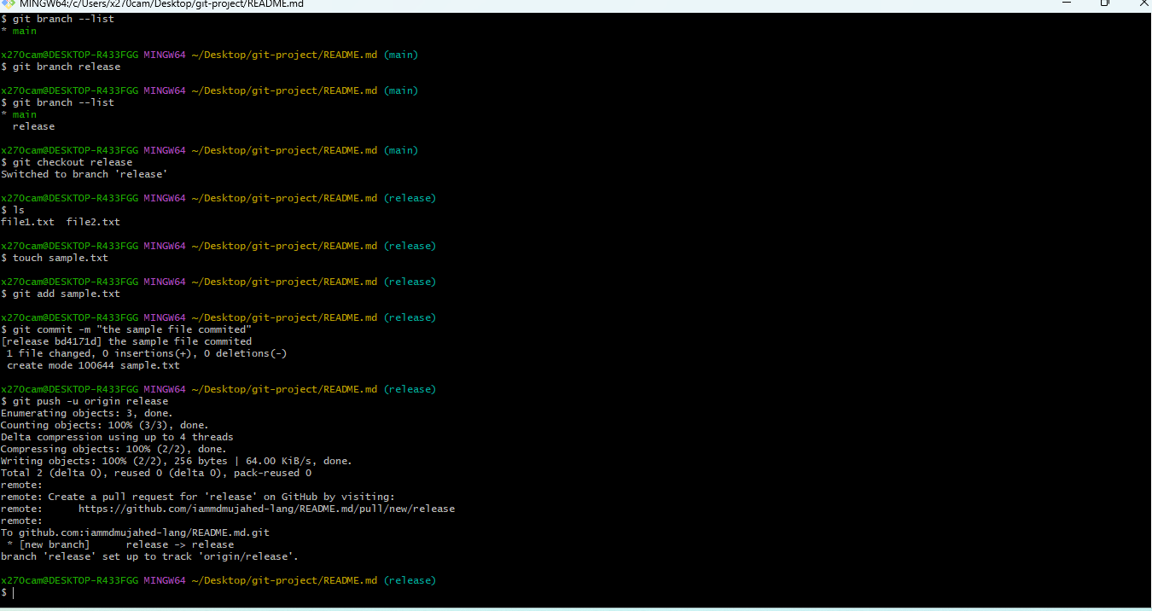

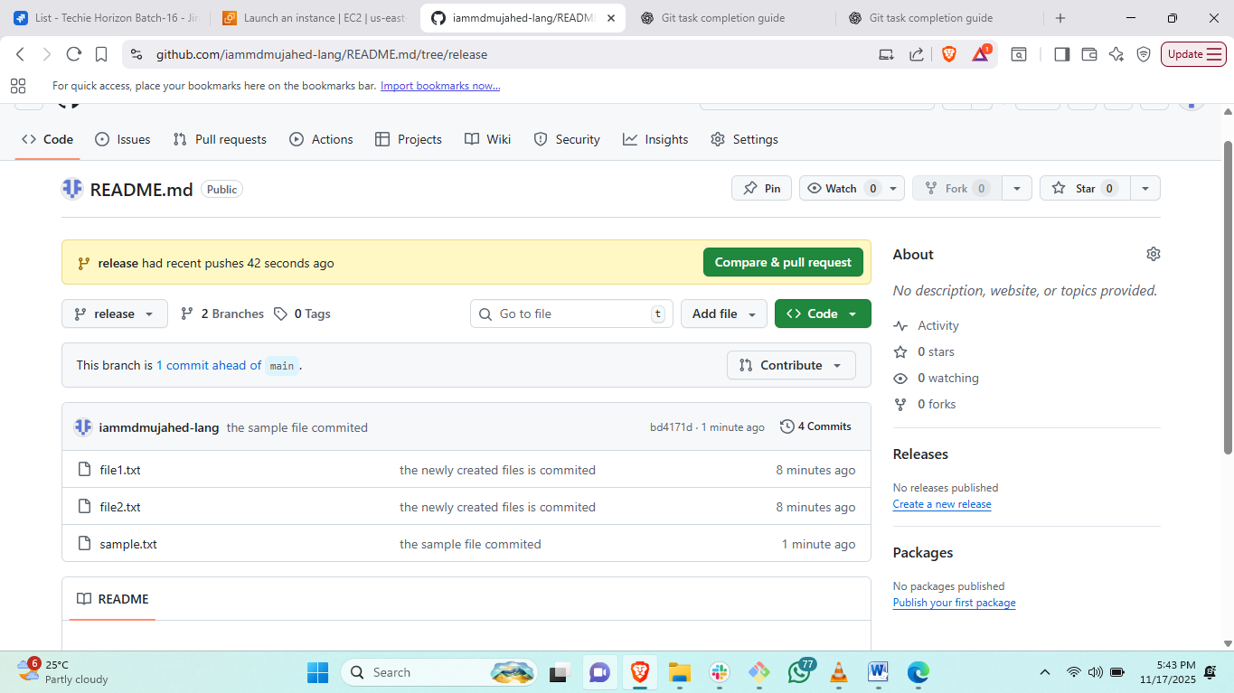

Steps: to create new branch <git branch “branchname”>

#to check the branch list<git branch --list>

# to switch to created branch <git checkout “branch name”>

#create a sample file and add to tracking area <git add .>

#then commit and push to origin branch name<git commit –m ><git push –u origin release>

1. Create a branch in github and clone that to local.

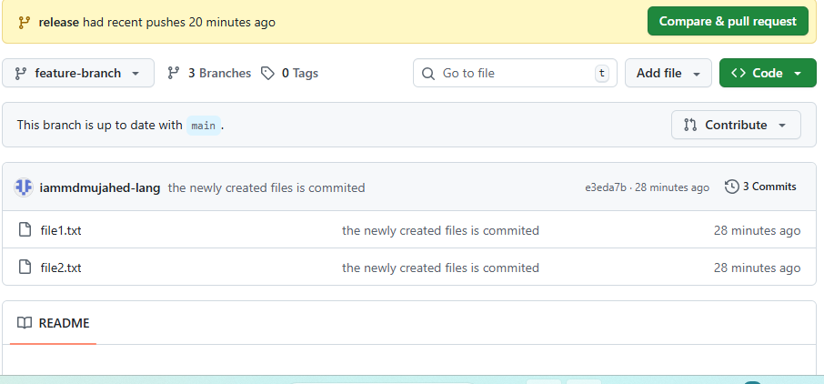



Steps: to create new branch from git hub go to git hub and create branch

# to clone the selected branch<git clone –-branch “branch name” repo url>

1. Merge the created branch with master in git local.

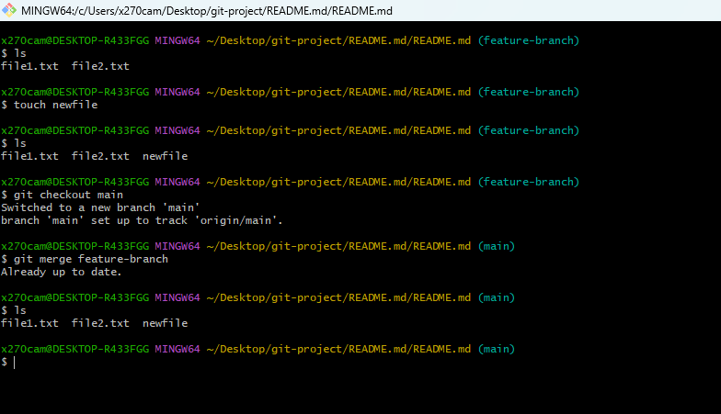

Steps: to merge newly created branch switch to main branch <git checkout main>

# git merge “branch name” to merge the branch

1. Merge the created branch with master in github by sending a pull request.

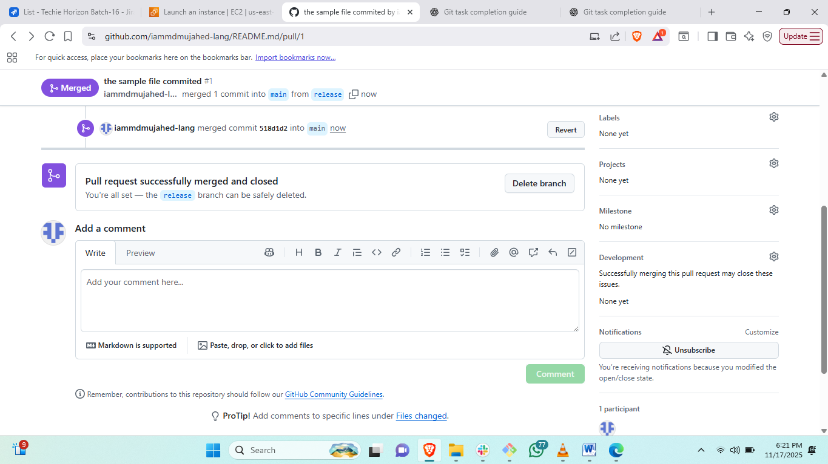

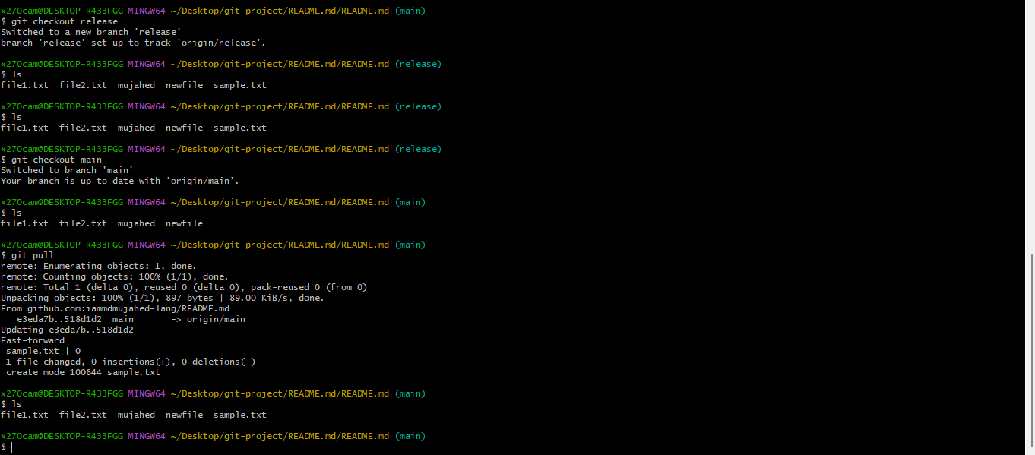

Steps: go to github account and create pull request and seleck branches which branch should be shared to each other and create pull .

#then go to local and change to main branch and<git pull>

1. Create a file in local and send that to branch in github.

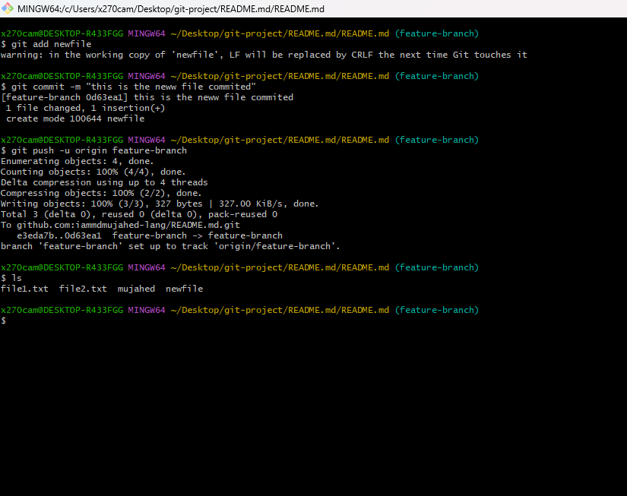

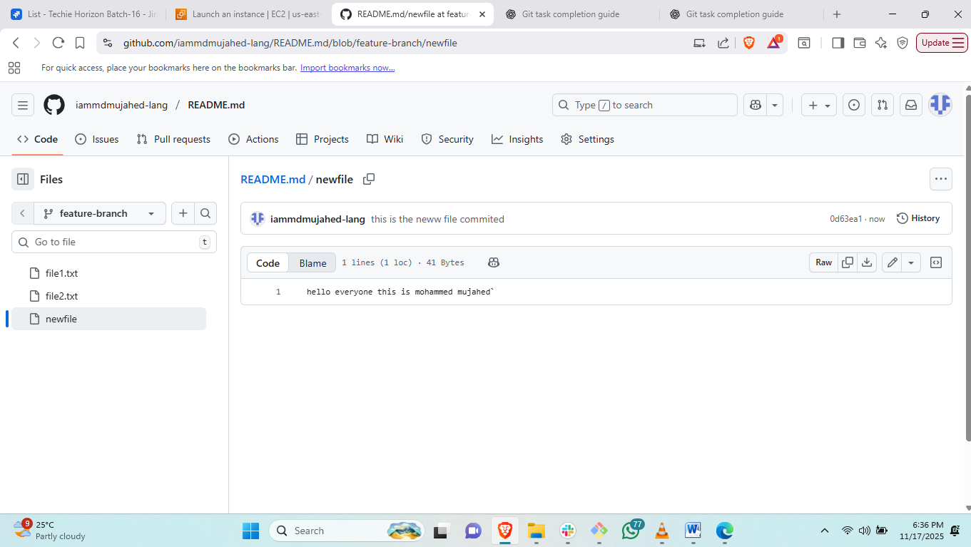

Steps: create a file in local and add to tracking area<git add .>

# git commit –m filrename

#git push –u origin branch-name

1. Clone only a branch from github to local.

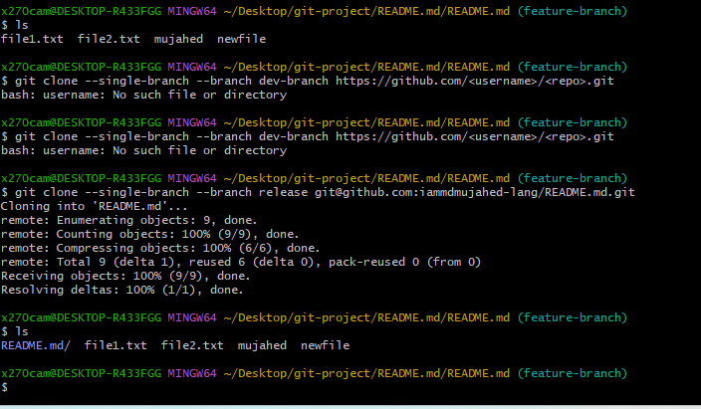

Steps: to clone the release branch to feature branch <git clone --single-branch --branch dev-branch [https://github.com/<username>/<repo>.git](https://github.com/%3cusername%3e/%3crepo%3e.git)>

1. Create a file with all passwords and make that untrackable with git.

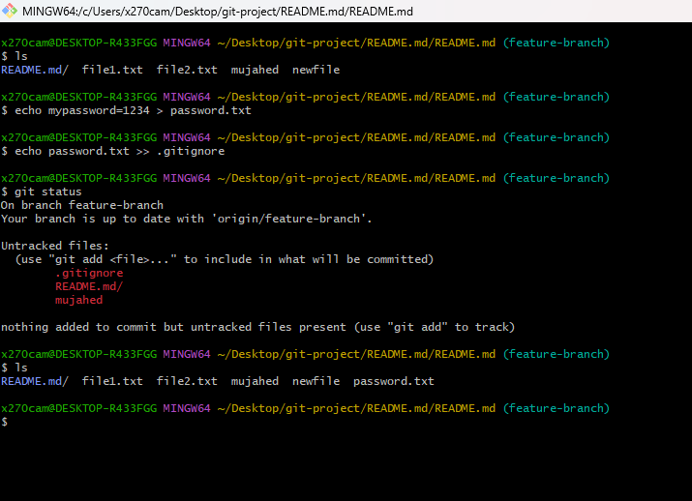

Steps: create password.txt file and create anethor file with .git.ignore

#then edit the file .git.ignore and add the file name password file name.

#then look for <git status>

1. Make a commit and make that commit reset without savings changes.

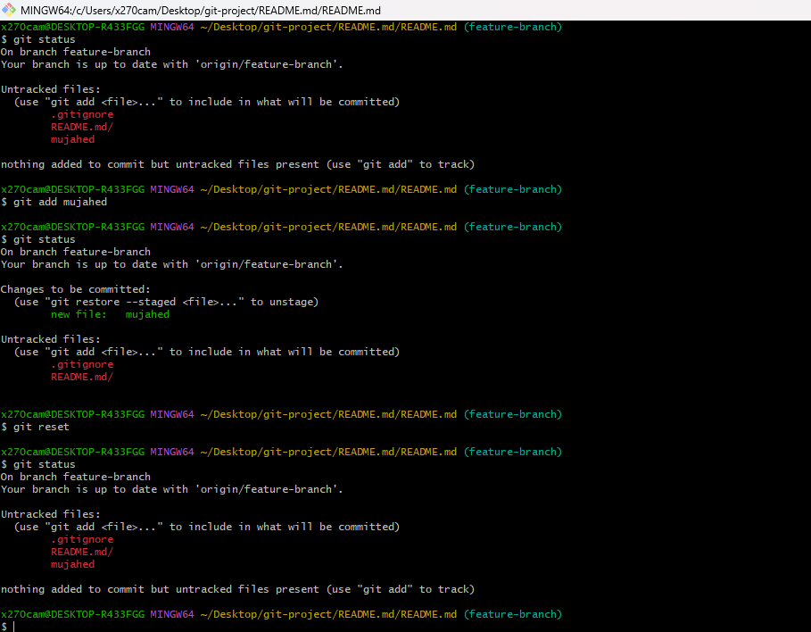

Steps:to reset the file from tracking area to untracking area.

Git add <filename>

Git status: then git reset to move back to untracking area.

1. Revert a commited commit to the older version.

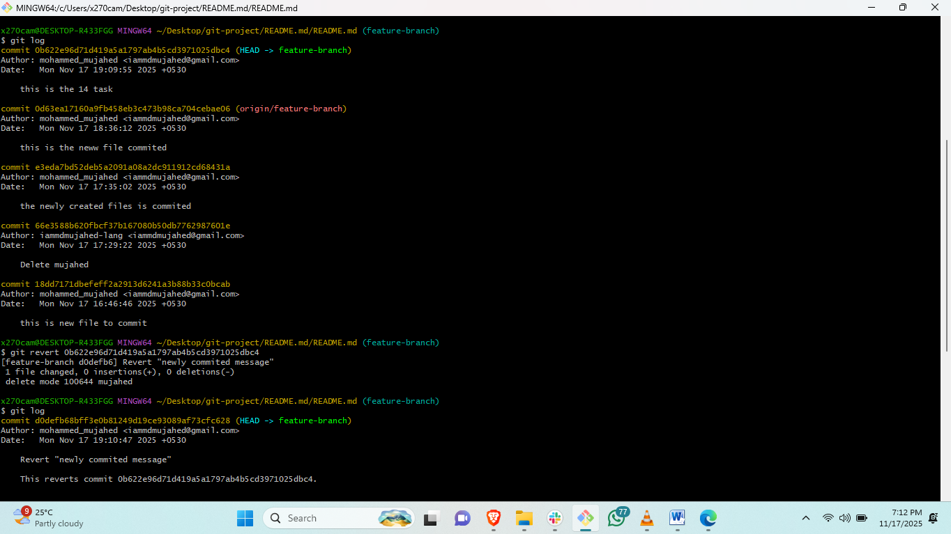

Steps: to revert the commit we need to check the commit id by<git log>then

#git revert <commit id> then edit the commit message. And save file

1. Push a file to stash without savings the changes and work on another file.

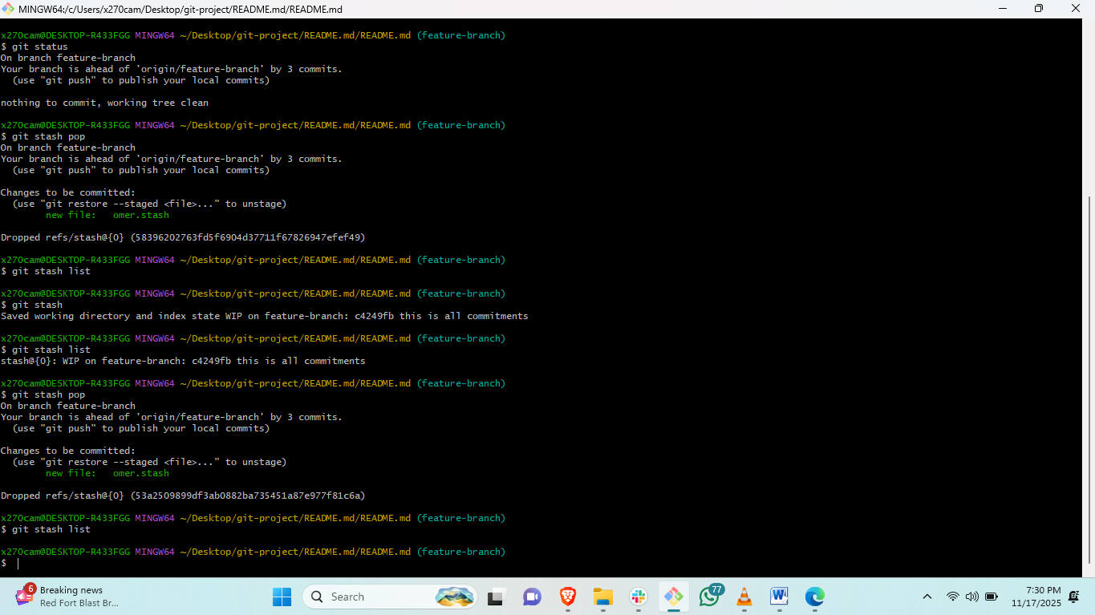

Steps: create a file and add to tracking area<git add filename>

# then check status <git status>

#<git stash>

#git status and check ls it will save in stash memory.

#<git stash pop>

1. Undo the stash file and start working on that again.



1. Generate a ssh-keygen and configure into github.

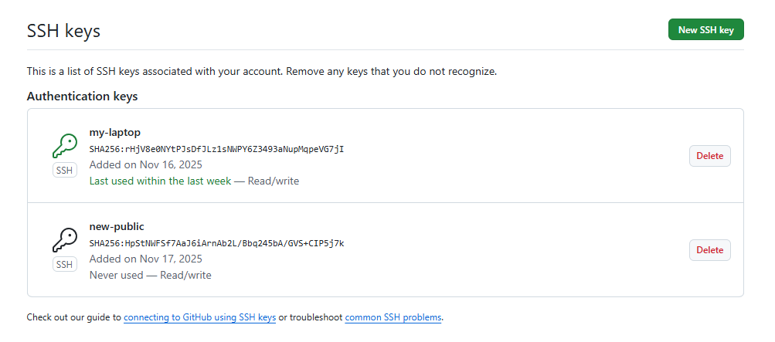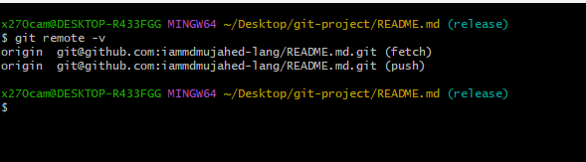

Steps: firstr generate ssh-keygen<ssh-keygen>and copy public key and go to github.

#go to setting and click on ssh and add ssh remote and paste public key.

#and go to gitbash and check <git remote -v>

1. Basic understanding of .git file.

#.git is a local repository which we initiate in our local when we start project.

#.git repository is the heart of our project. Because everything you are creating will be store in .git repo only.

#if you delete .git you have nothing related to you poroject.

# .git holds no of derectories and files by default.

What are the things available by default in .git.

*Head-

*configure file

*hook

*info

*logs

Thise will be available by default.

1. Check all the logs of git.

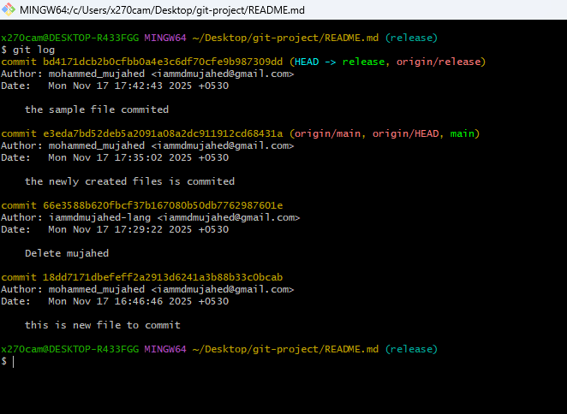

Steps: to check the log files in git <git log>

1. Rename the commit message.

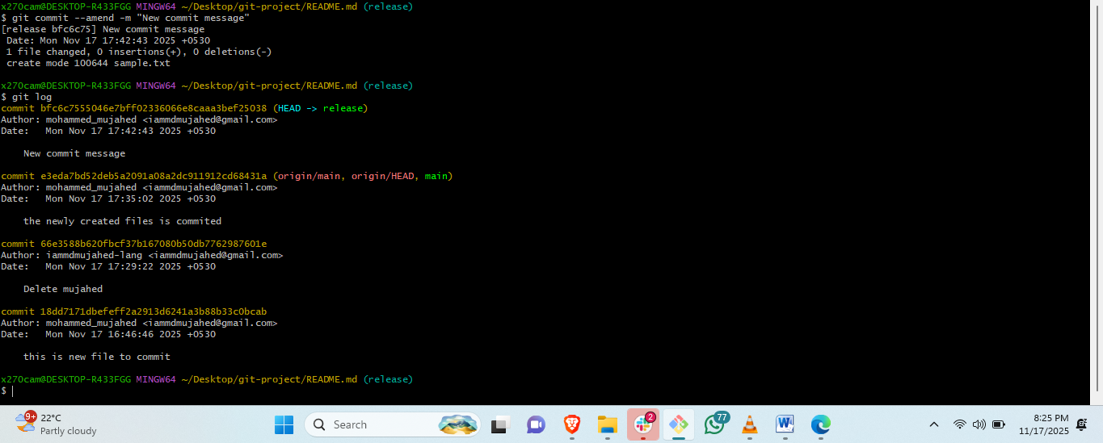

Steps: to change the commit message.< git commit --amend -m "New commit message" >

1. Merge multiple commits into single commit.

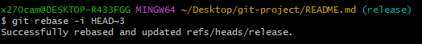

Steps: <git rebase -i HEAD~3>this is to commit three commits in on commit.